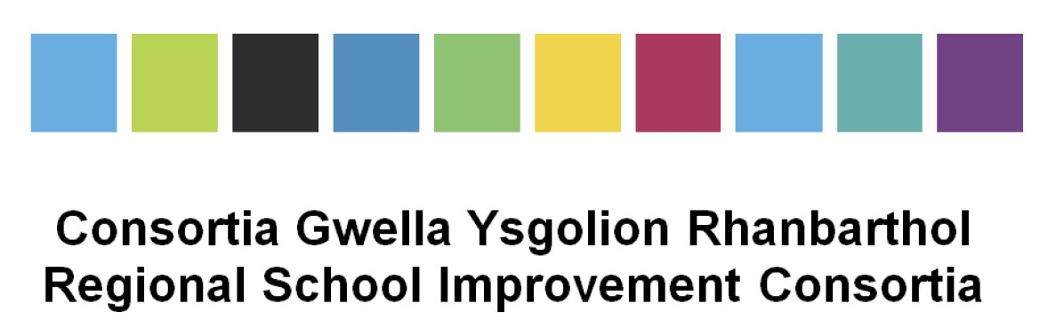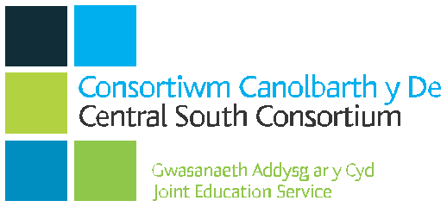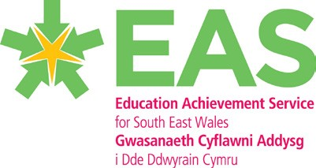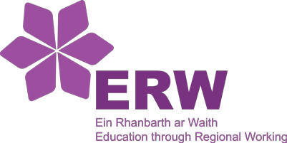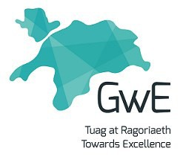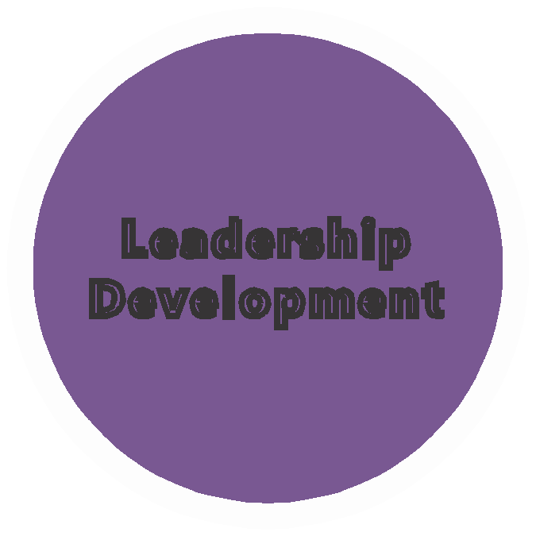

Senior Leaders Development Programme

2020

Leadership
Development
Senior Leaders Development Programme

This programme is for leaders who have overall responsibility for an aspect of leadership across an establishment. This includes senior curriculum/pastoral leaders and members of a senior leadership team, such as assistant or deputy headteachers.

It consists of five modules that allows the participant to reflect on their individual effectiveness as a leader.

The participant will work individually and collectively with others as leaders of learning organisations. This is a national programme co-ordinated by regional consortia, utilising a range of delivery partners.
This programme will offer accreditation in partnership with Trinity St David’s (Yr Athrofa) and Bangor University.

Time | Activity | Led By | Outline | Support
Phase 1
Autumn term 2020 | Application process | Regional Coordinators | - National application process that will include individual reflection against professional standards for leadership  - Applications to be submitted regionally  - Notification of outcomes | Regional Consortia
 | Notification | Regional Consortia
Phase 2
Pre January 2021 | Completion of LSR | Regional Consortia | An electronic template is available for this
 | Allocation of a Leadership Coach | Regional Consortia | Training provided for Leadership Coach
Phase 3

Delivery of modules
January – December 2021

Module 1 | Values and Dispositions, Self Reflection | Regional consortia and facilitation team
 |  |  | - An introduction to the programme  - National picture  - Self-reflection (LSR)  - What is senior leadership  - The role of a senior leader  - Leadership v Management  - Leadership styles  - Emotional intelligence and well-being  Intersessional task –  What is your vision and strategic overview? | Leadership Coach fulfilling duties and coordinating appropriate network activities as required.
Module 2 | Working with others | Regional Consortia and Facilitation Team
- Feedback from intersessional task, sharing of vision with Trust group
- Leading staff
- Developing effective teams
- Professional learning
  - Innovation
  - Professional inquiry
  - Mapped into vision
- What does evaluation look like across the school?

Module 3 | Coaching and Mentoring | Regional Consortia and Facilitation Team
- Half day on coaching and mentoring skills
- Feedback including challenging conversations
- Effective PM systems

Module 4 | Pedagogy | Regional consortia and Facilitation Team
- Teaching & Learning
- What is excellence?
- The role of the senior leader in teaching and learning
- Internal data
- Quality assurance, monitoring and evaluation
- Creating a teaching & Learning culture
- WG Senior Leader curriculum reform – managing change

Module 5 | Collaboration | Regional Consortia and Facilitation Team
- Collaboration with other schools, clusters, outside agencies
- Effective use of resources
- Making good use of the budget
- Case study (to be introduced in session 1 – Leadership Experience Task – LET)

